Project Design Phase-II

Technology Stack (Architecture & Stack)

Date | 20 February 2026
Team ID | LTVIP2026TMIDS70508
Project Name | Learn Hub : Your Center for Skill Enhancement
Maximum Marks | 4 Marks

Technical Architecture:
The Learn Hub platform follows a 3-tier MERN architecture consisting of Frontend (React), Backend (Node.js & Express), and Database (MongoDB). External APIs such as Payment Gateway services are integrated for secure transactions.

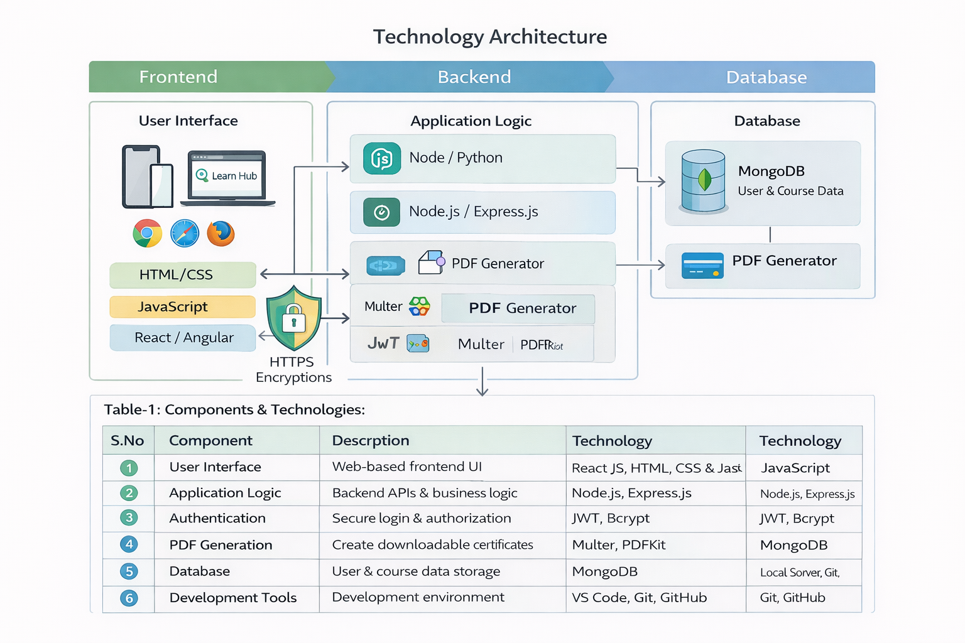

Table-1: Components & Technologies
S.No | Component | Description | Technology
1 | User Interface | Web-based frontend UI | React JS, HTML, CSS, JavaScript
2 | Application Logic | Backend APIs & business logic | Node.js, Express.js
3 | Database | User & Course Data Storage | MongoDB
4 | Authentication | Secure login & authorization | JWT, Bcrypt
5 | File Handling | Video uploads & certificate generation | Multer, PDFKit
6 | Development Tools | Development environment | VS Code, Git, GitHub

Table-2: Application Characteristics
S.No | Characteristics | Description | Technology
1 | Open-Source Frameworks | MERN stack usage | React, Node.js, Express
2 | Security | Password hashing & token auth | JWT, HTTPS
3 | Scalability | 3-tier scalable architecture | Cloud deployment
4 | Availability | Cloud hosting with uptime | Render / Vercel
5 | Performance | Optimized APIs & DB indexing | MongoDB indexing

